IAM TASK:-
1. Create one IAM user and assign EC2 and S3 full access roles
First click on create user
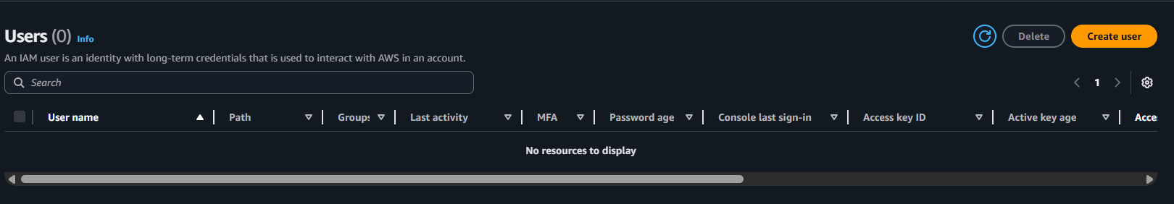
Add user name also tick on provide user access to the aws management console then click on next make sure set your password for the user
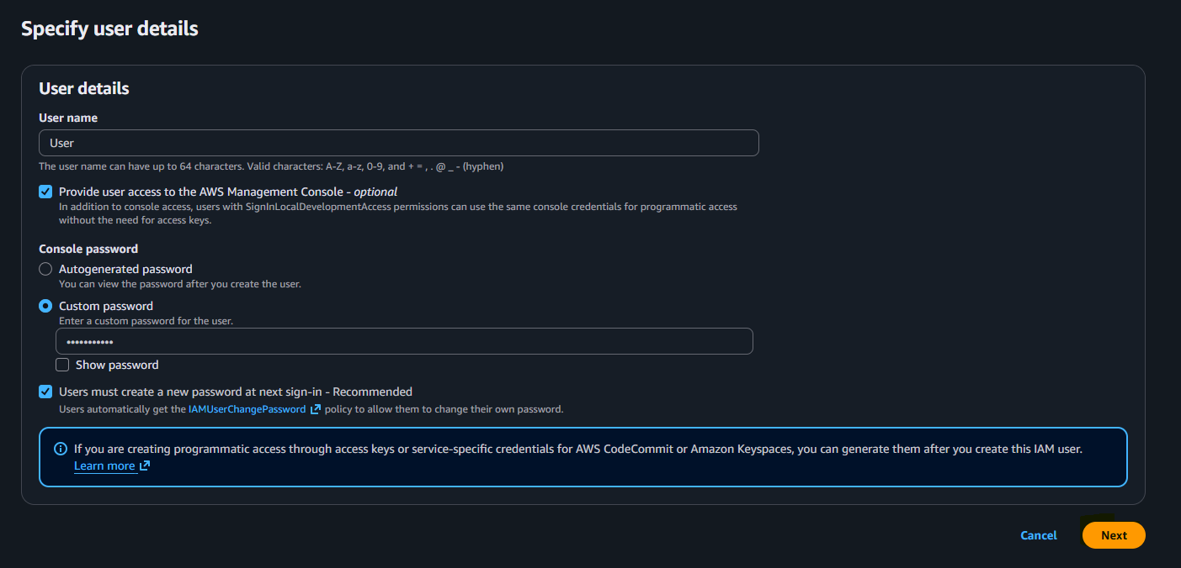

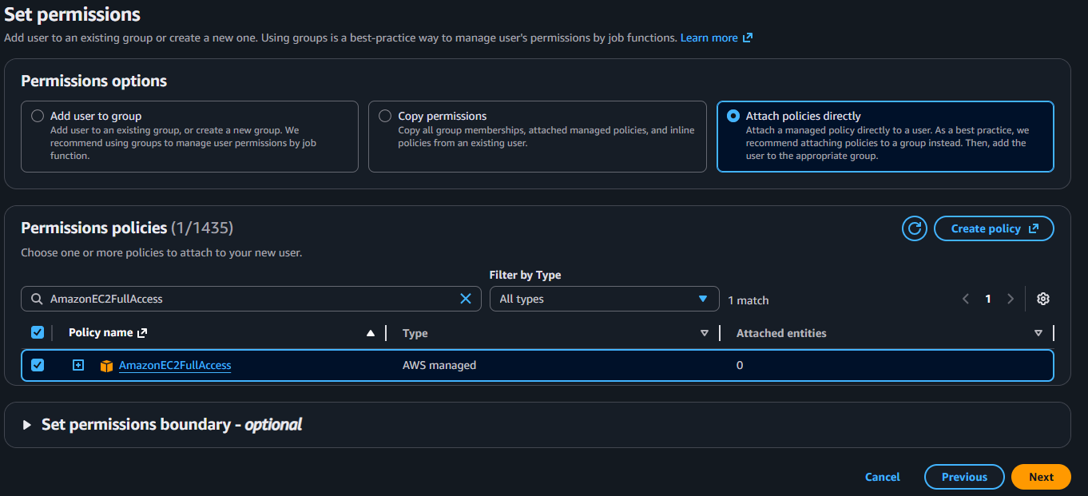
now conform permission after click on create user
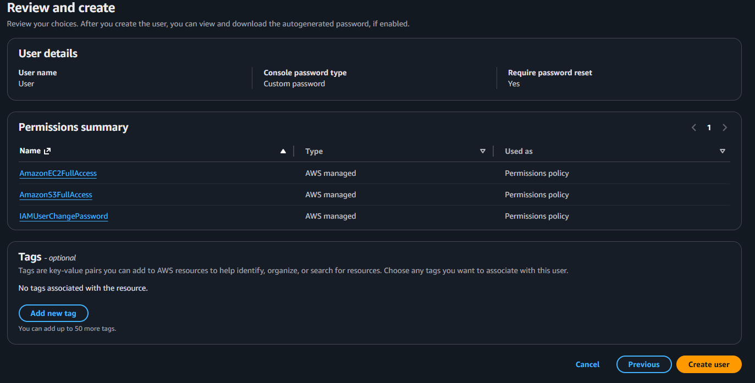
Now our user has successfully create you see it password & name
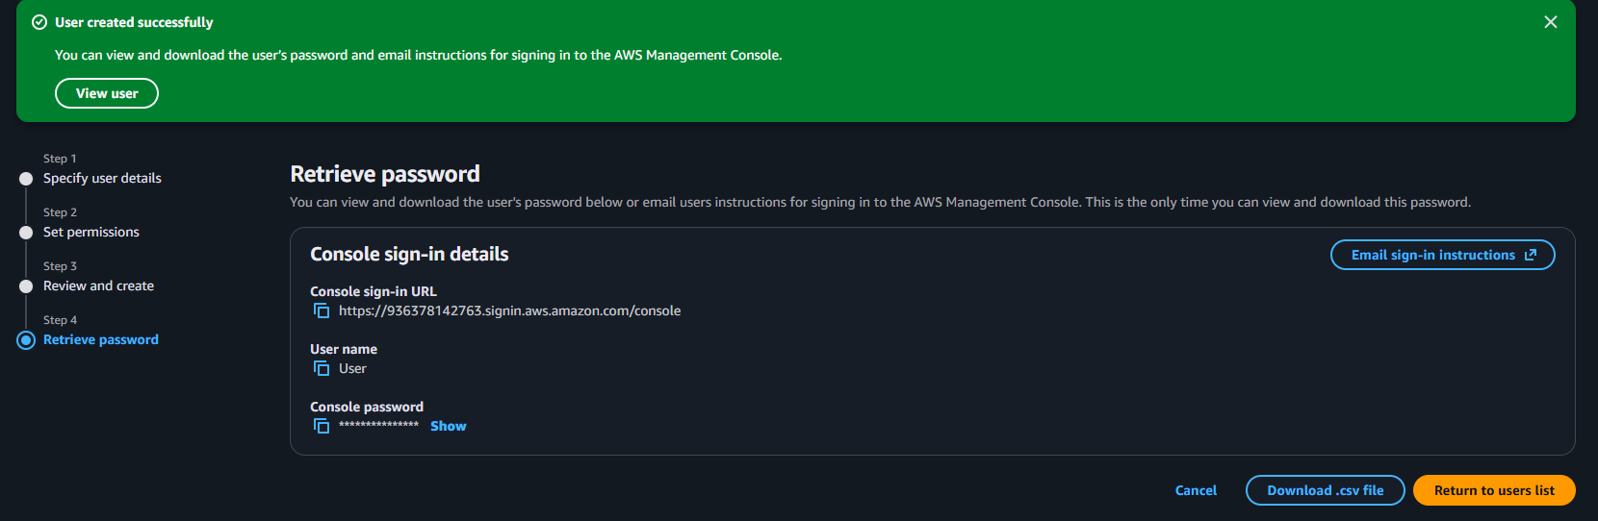

2. Create one group in IAM and assign read access for EC2.
First go user group then click on create group
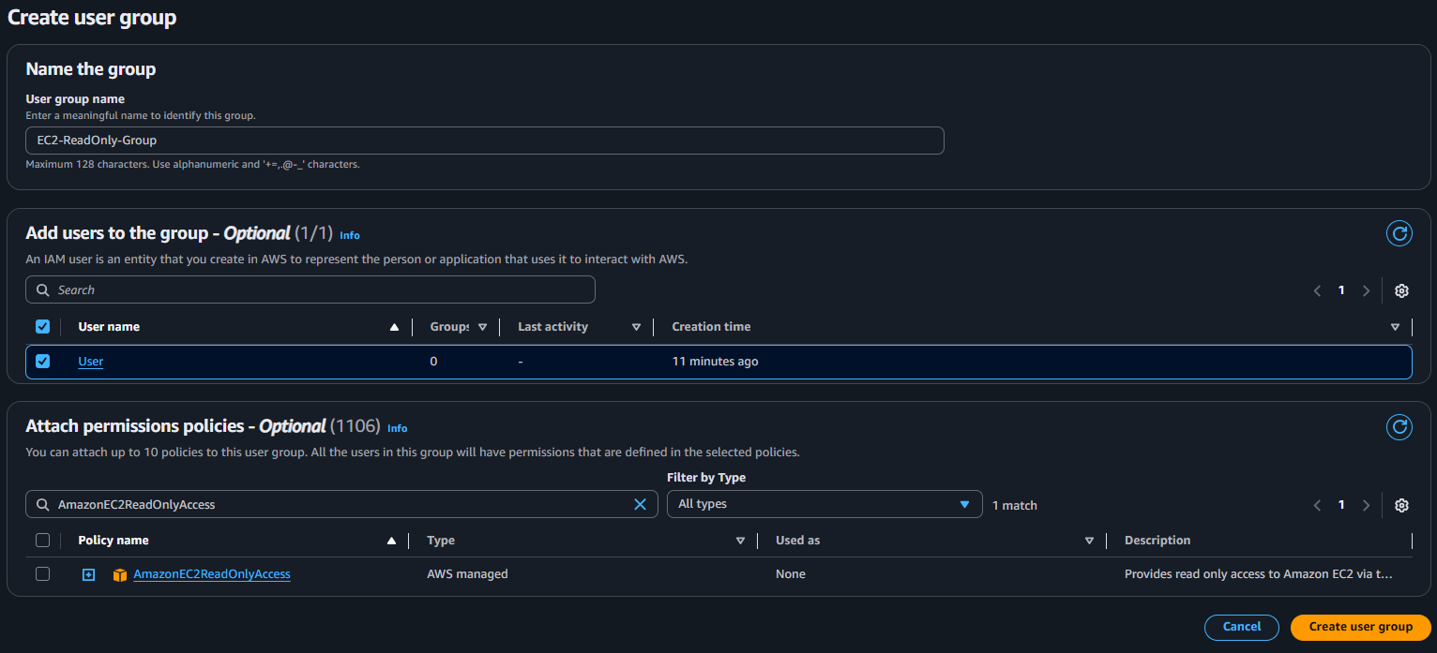
now our group is successfully create
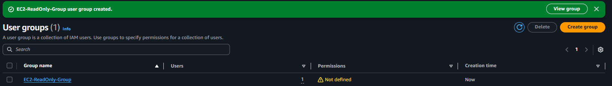

3. Create a new user named "Devops" and add to the group created in task
First go user and click on create user
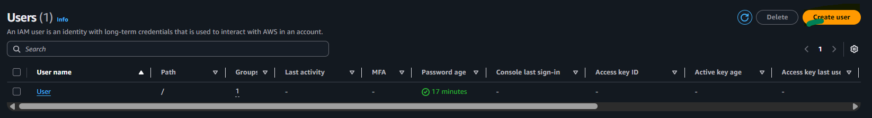
Now set name “ DEVOPS” then click next
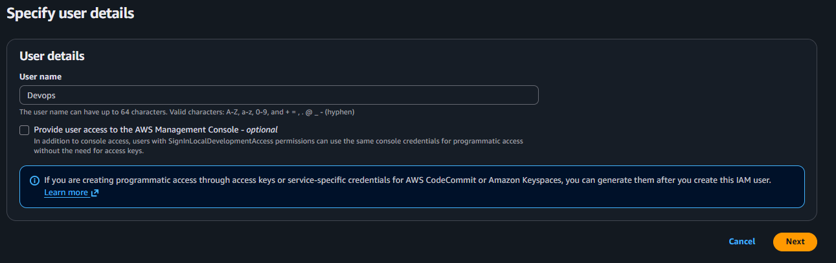
Set permission: Add user to group then click on next
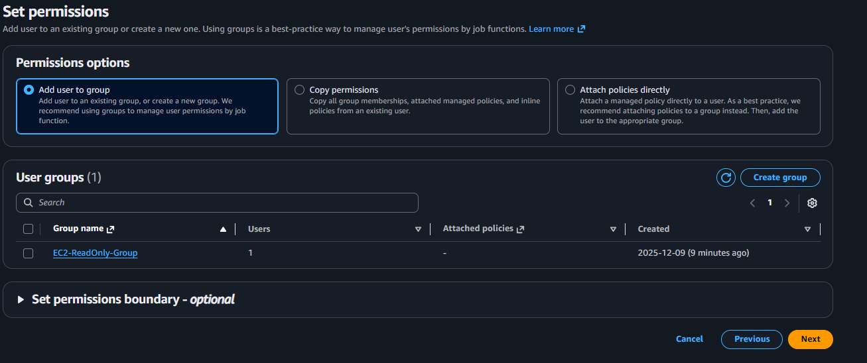
Now our new user has been create
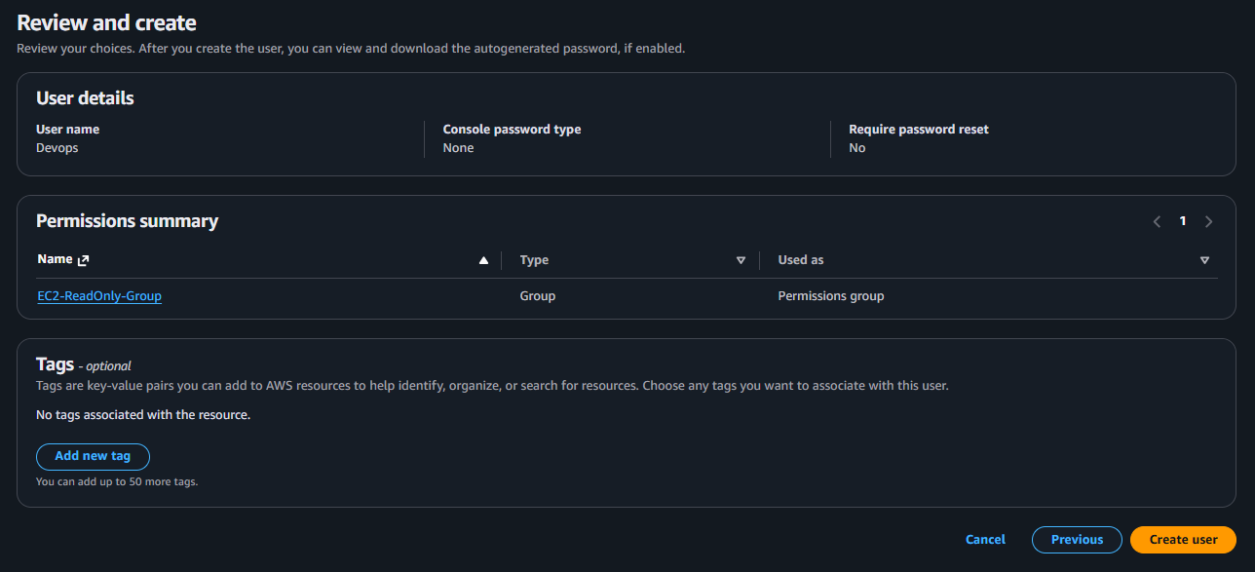

4. Write a bash script to create an IAM user with VPC full access.
Navigate to IAM and Create a Access Key and password
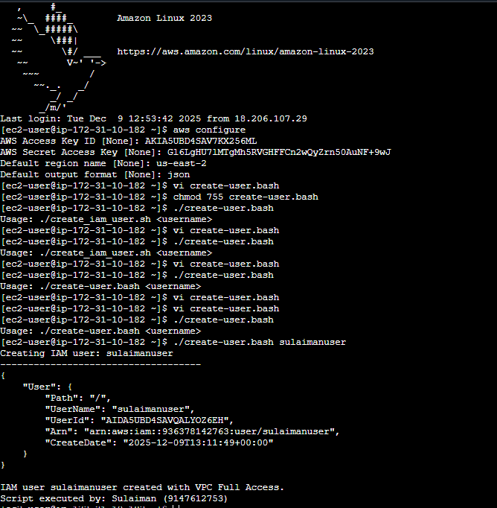

5. Create an IAM policy to allow EC2 access for a specific user in specific regions only.
Then iam then goe Left side click Policies
Click Create Policy then click on json
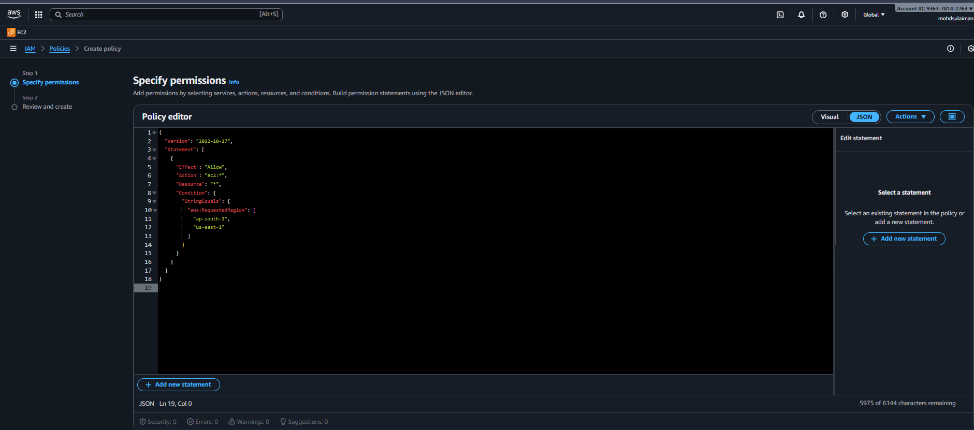

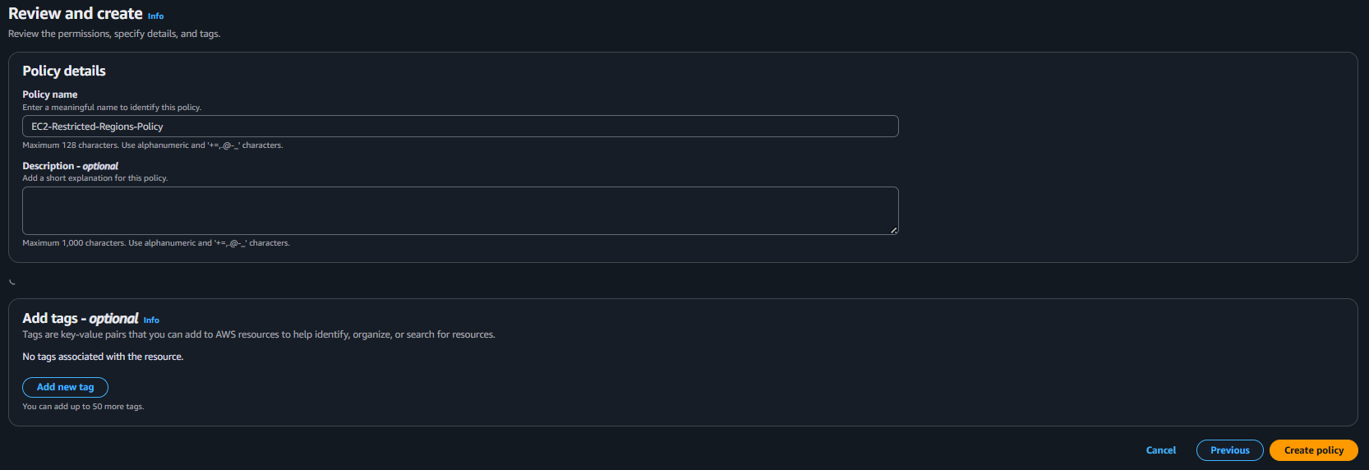
Now we have polices
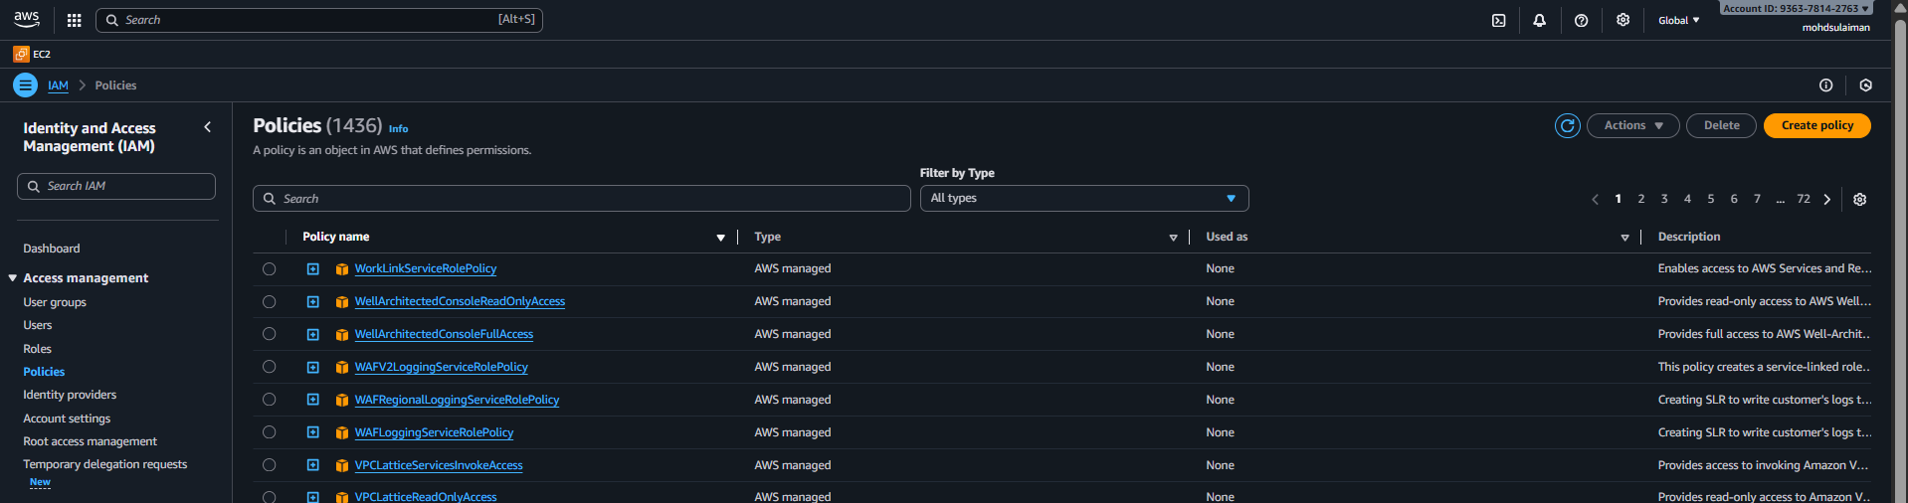

6.We have two accounts: Account A and Account B. Account A user should access an S3 bucket in Account B.
- Get the IAM User ARN from Account A
- In Account A:
- Go to IAM → Users → your user → Copy ARN
- Add Bucket Policy in Account B (Grant access to Account A user)
- Go to S3 → Bucket → Permissions → Bucket Policy
- Replace ACCOUNT_A_ID
Replace USERNAME
Replace bucket name
- Attach IAM Policy in Account A to allow S3 actions
- Now we need follow a and b bucket same steps
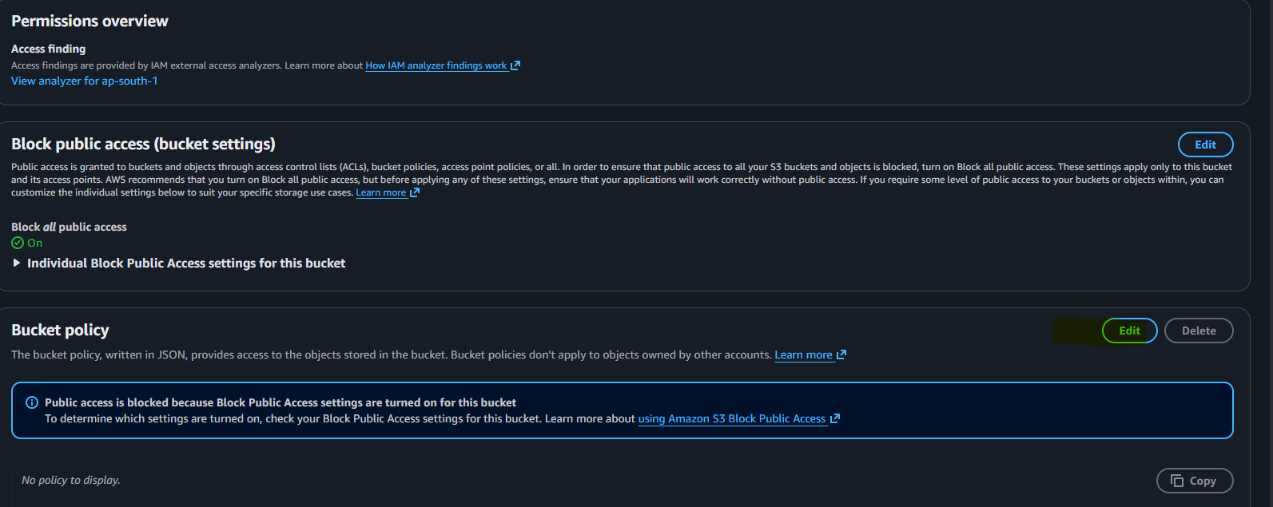
Paste your script in bucket policy